Project Design Phase-II
Data Flow Diagram & User Stories
Date | 19 July 2026
Team ID | (Assign as per SmartBridge Portal)
Project Name | Strategic Product Placement & Business Intelligence Suite
Team Members | Vishnu Edara (Team Lead)  Rama Krishna Siripurapu  Sravanthi Nagelli  Liven Tulugu  Jaya Veera Chaitanya Vuyyuru
Maximum Marks | 4 Marks

Data Flow Diagram
The diagram below depicts how retail placement data enters the system, how it is transformed, and where it is stored and consumed.
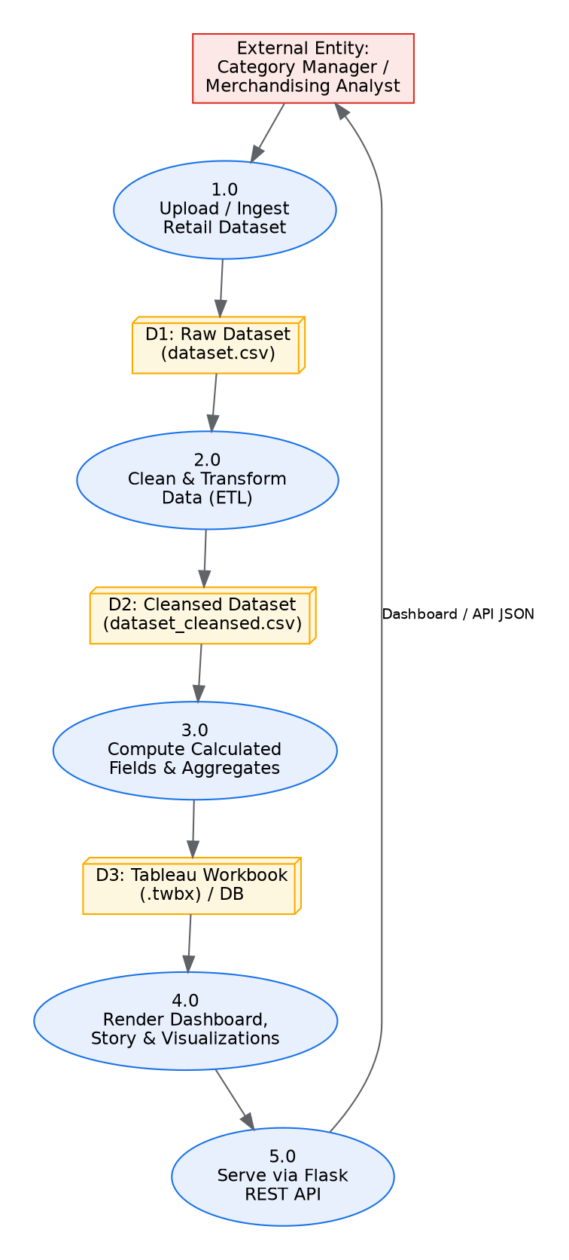

User Stories
Use the table below to review all user stories for the Strategic Product Placement & Business Intelligence Suite.
User Type | Functional Requirement (Epic) | User Story Number | User Story / Task | Acceptance Criteria | Priority | Release
Category Manager (Web user) | Dashboard Access | USN-1 | As a category manager, I can log into the BI portal so I can view the retail placement dashboard. | I can access the dashboard after authentication. | High | Sprint-1
Category Manager (Web user) | Filtering | USN-2 | As a category manager, I can filter the dashboard by product category, shelf height and store location. | Charts and KPIs update in under 2 seconds on filter change. | High | Sprint-1
Retail Analyst | KPI Monitoring | USN-3 | As an analyst, I can view calculated KPI cards (revenue, profit, margin, conversion) for an instant health check. | KPI values match the underlying Tableau calculated fields. | High | Sprint-1
Retail Analyst | Data Access (API) | USN-4 | As an analyst, I can call the REST API endpoint /api/v1/placements to pull JSON placement data for external reporting. | Endpoint returns valid JSON with correct schema. | Medium | Sprint-2
Administrator | Data Refresh | USN-5 | As an admin, I can trigger the ETL pipeline to refresh the cleansed dataset so dashboards reflect the latest data. | prepare_data.py runs end-to-end and regenerates dataset_cleansed.csv without errors. | High | Sprint-2
Category Manager / Analyst | Storytelling | USN-6 | As a viewer, I can navigate the 5-scene Tableau storyboard to follow the merchandising narrative. | Scenes advance sequentially with correct narrative text. | Medium | Sprint-2
Category Manager | AI Recommendations | USN-7 | As a category manager, I can view AI-generated planogram recommendations to act on optimization suggestions. | Recommendation panel renders actionable text suggestions. | Low | Sprint-3

